**Written assignment 2**

**1.（15‘）Divide and Conquer**

Suppose you are given an array A[1..n] of sorted integers that has been circularly shifted k positions to the right. For example, [31,43,3,17,26,28] is a sorted array that has been circularly shifted k = 2 positions, while [26,28,31,43,3,17] has been shifted k = 4 positions. We can obviously find the largest element in A in O(n) time. Describe an O(logn) algorithm by using a divide and conquer solution.

We can use Binary Search.

|  |
| --- |
| Function FindLargest(A, n):  low ← 1  high ← n  While low ≤ high:  mid ← (low + high) // 2    If mid < n AND A[mid] > A[mid + 1]:  Return A[mid]  If A[mid] ≥ A[low]:  low ← mid + 1  Else:  high ← mid - 1  Return -1 |

**2. (15’) Heap Sort**

Sort the array {1, 3, 7, 4, 5, 6} with a maximum heap without using extra memory. Write down the content of the array every time an insert() or a deleteMax() operation completes. The initial state and the array content after the first two insertions are already written for you:

0: initial state

| 1 | 3 | 7 | 4 | 5 | 6 |

1: insert (1)

| 1 | 3 | 7 | 4 | 5 | 6 |

2: insert (3)

| 3 | 1 | 7 | 4 | 5 | 6 |

3: insert (7)

| 7 | 1 | 3 | 4 | 5 | 6 |

4: insert (4)

| 7 | 4 | 3 | 1 | 5 | 6 |

5: insert (5)

| 7 | 5 | 3 | 1 | 4 | 6 |

6: insert (6)

| 7 | 5 | 6 | 1 | 4 | 3 |

7: deleteMax()

| 6 | 5 | 3 | 1 | 4 | 7 |

8: deleteMax()

| 5 | 4 | 3 | 1 | 6 | 7 |

9: deleteMax()

| 4 | 1 | 3 | 5 | 6 | 7 |

10: deleteMax()

| 3 | 1 | 4 | 5 | 6 | 7 |

11: deleteMax()

| 1 | 3 | 4 | 5 | 6 | 7 |

12: deleteMax()

| 1 | 3 | 4 | 5 | 6 | 7 |

**3. (10’) Binary Search Trees**

Verify the binary search tree. Given a binary tree root node, determine whether it is a valid binary search tree by writing the pseudo code of the function

Boolean isBST(root, lower, upper).

A valid binary search tree is defined as follows:

* The left subtree of a node only contains numbers less than the current node.
* The right subtree of a node only contains numbers greater than the current node.
* All left and right subtrees must also be binary search trees.

Note: The number of nodes in the tree is in the range [MIN_VALUE, MAX_VALUE], i.e., MIN_VALUE <= Node.key <= MAX_VALUE. In the function isBST(root, lower, upper), lower and upper are the two boundaries of the keys of a valid BST subtree.

|  |
| --- |
| Function isBST(root, lower, upper):  If root is NULL:  Return True  If root.key ≤ lower OR root.key ≥ upper:  Return False  Return isBST(root.left, lower, root.key) AND isBST(root.right, root.key, upper) |

**4. (15’) AVL Trees**

Construct an AVL tree by inserting the input array {13, 7, 25, 58, 80, 15, 82, 6, 65, 71, 30, 60}. Draw the three trees after inserting the last three elements: 71, 30, and 60, respectively.

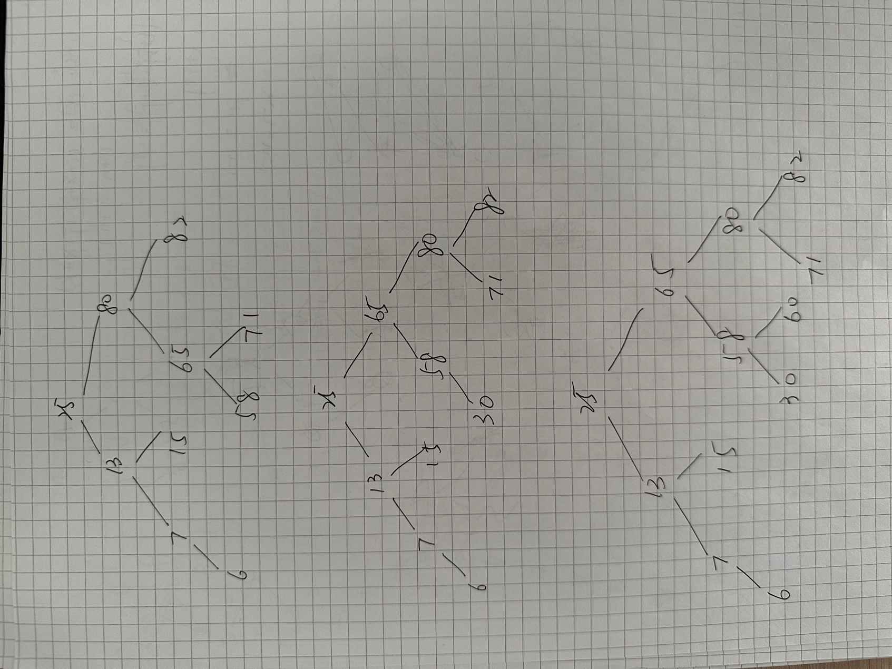

**5. (30’) B+ Trees**

5.1. *(10’)* Suppose you are managing employee records on a computer with the following setting:

* Computer hard disk access is block-based and the size of one block is *2048 bytes*.
* The size of each employee record is *256 bytes* (including the primary key).
* The primary key for an employee record is of type *long* long *(16 bytes).*
* The size of a pointer is 8 bytes.

You decide to store the data using a B+ tree. Propose the best setting for *M* and *L.* Show the steps that lead to your proposal.

Note: The definition of *M* and *L is* as described in the lecture slides.

Thus

5.2. *(20’)* In this question, we use a B+ tree with M=L=4. The initial B+ tree is shown in Figure 1.

|  |  |  |
| --- | --- | --- |
| 7 | 18 |  |

|  |  |  |  |  |
| --- | --- | --- | --- | --- |
| 2 3 4 6 |  | 7 9 |  | 18 23 41 42 |

**Figure 1: The initial B+ Tree**

1. *(10’)* Given an insertion sequence *{22, 12, 32}*, draw the three B+ trees after each insertion, respectively. Please start from the initial B+ tree shown in Figure 1.

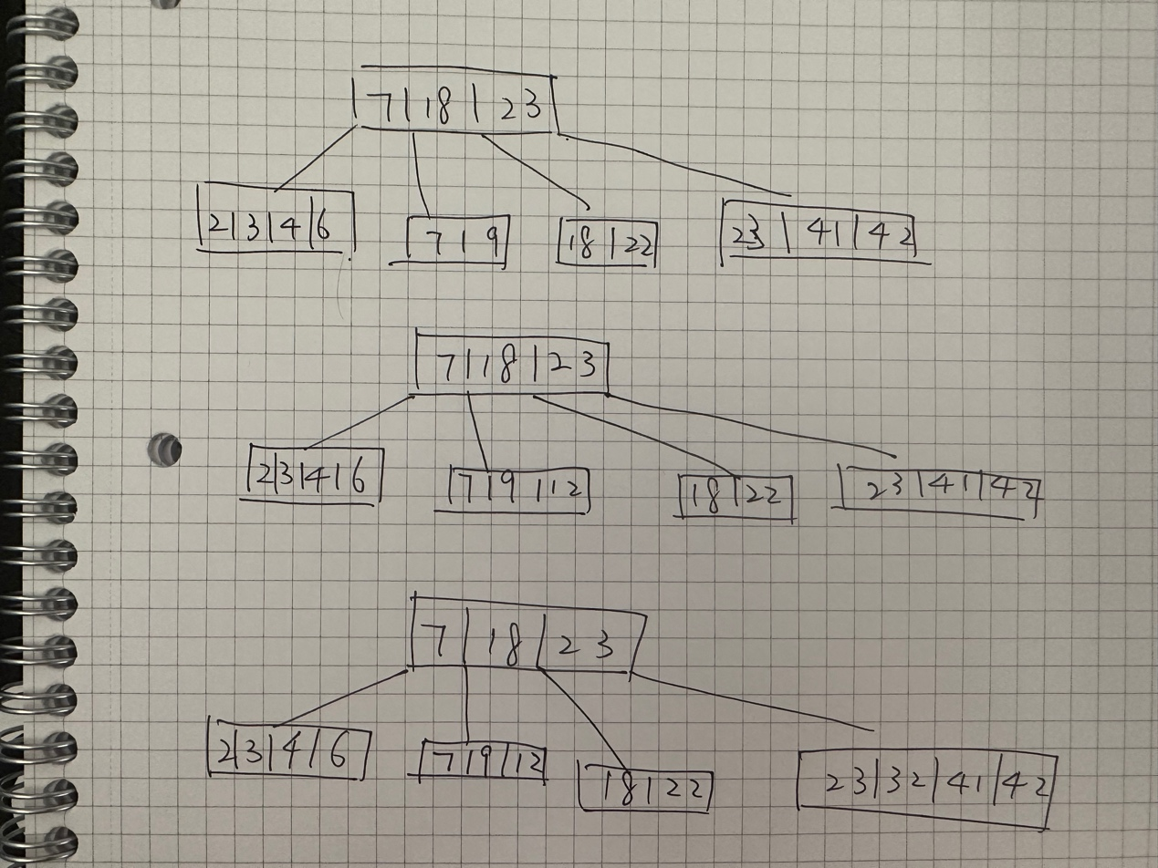

1. *(10’)* Given a deletion sequence *{ 23, 9, 7}*, draw the three B+ trees after each deletion. Please start from the initial B+ tree shown in Figure 1.

*Note: please strictly follow the lecture notes when you do the operations.*

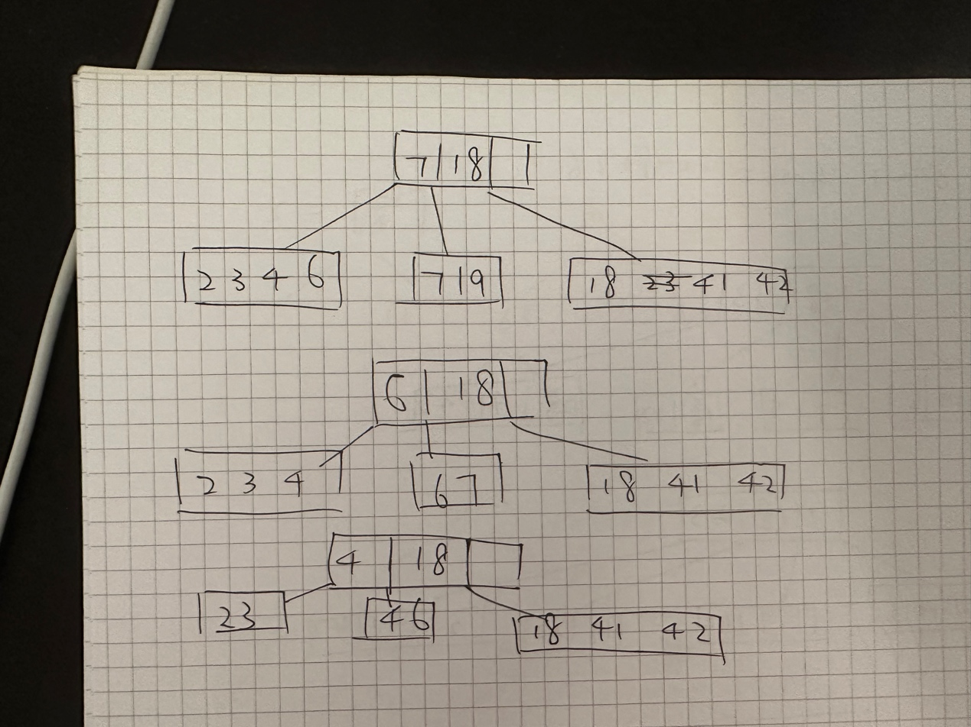

**6. (15’) Graph**

Given a graph as shown in Figure 2. Imagine that node 6 is the vertex:

1. *(2’)* Write out its adjacency matrix.
2. *(3’)* Write out its adjacency List.
3. *(10’)* Use the algorithm of “BFS + Path Finding” (as shown in Lecture 15, page 3) to work out the BFS tree step by step.

|  |  |  |  |  |  |  |  |  |  |  |
| --- | --- | --- | --- | --- | --- | --- | --- | --- | --- | --- |
|  | 0 | 1 | 2 | 3 | 4 | 5 | 6 | 7 | 8 | 9 |
| 0 | 0 | 0 | 0 | 0 | 0 | 1 | 1 | 0 | 0 | 0 |
| 1 | 0 | 0 | 0 | 0 | 0 | 0 | 1 | 1 | 0 | 0 |
| 2 | 0 | 0 | 0 | 0 | 0 | 0 | 0 | 1 | 1 | 0 |
| 3 | 0 | 0 | 0 | 0 | 0 | 0 | 0 | 0 | 1 | 1 |
| 4 | 0 | 0 | 0 | 0 | 0 | 1 | 0 | 0 | 0 | 1 |
| 5 | 1 | 0 | 0 | 0 | 1 | 0 | 1 | 0 | 0 | 1 |
| 6 | 1 | 1 | 0 | 0 | 0 | 1 | 0 | 1 | 0 | 0 |
| 7 | 0 | 1 | 1 | 0 | 0 | 0 | 1 | 0 | 1 | 0 |
| 8 | 0 | 0 | 1 | 1 | 0 | 0 | 0 | 1 | 0 | 1 |
| 9 | 0 | 0 | 0 | 1 | 1 | 1 | 0 | 0 | 1 | 0 |

0: [5, 6]

1: [2, 6, 7]

2: [1, 7, 8]

3: [4, 8, 9]

4: [3, 5, 9]

5: [0, 4, 6, 9]

6: [0, 1, 5, 7, 9]

7: [1, 2, 6, 8]

8: [2, 3, 7, 9]

9: [3, 4, 5, 6, 8]

(c)

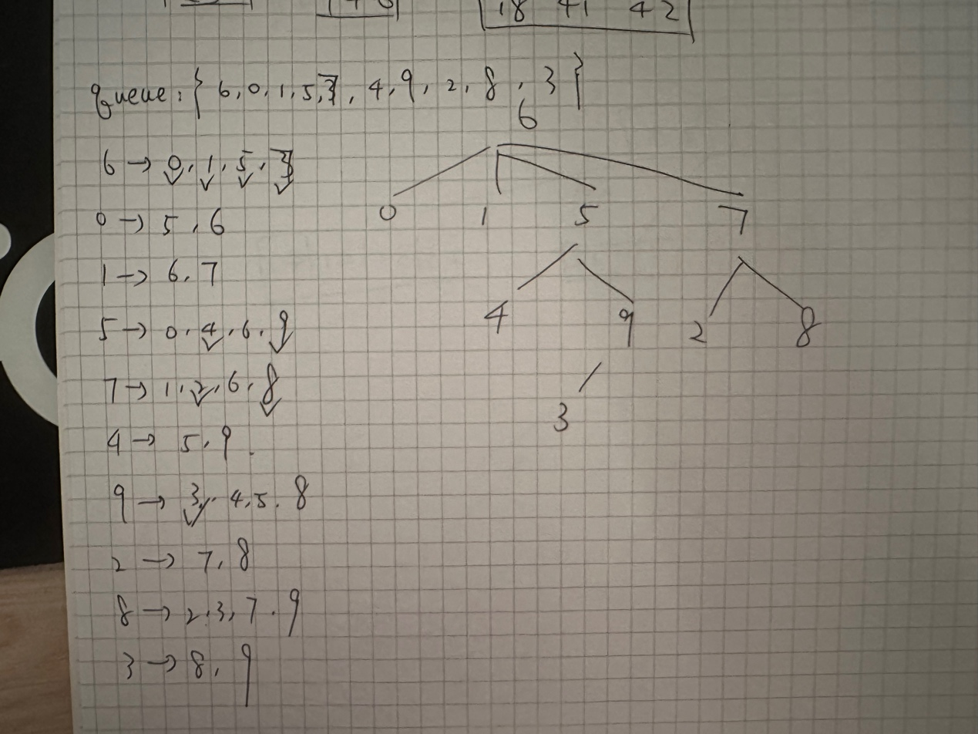

1

2

0

4

3

6

7

5

9

8

vertex

**Figure 2 The initial graph**